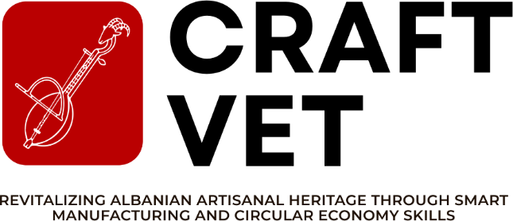

REPORT ON DISSEMINATION STRATEGY DOCUMENT
DELIVERABLE 4.1

Funded by the European Union. Views and opinions expressed are however those of the author(s) only and do not necessarily reflect those of the European Union. Neither the European Union nor the granting authority can be held responsible for them.
CRAFT-VET - Revitalizing Albanian Artisanal Heritage Through Smart Manufacturing and Circular Economy Skills

Project: 101241967 - ERASMUS-EDU-2025-CBHE

PROJECT INFO
Project title | Revitalizing Albanian Artisanal Heritage Through Smart Manufacturing and Circular Economy Skills
Project acronym | CRAFT-VET
Project reference number | 101241967
Funding scheme | ERASMUS-EDU-2025-CB-VET-WB
Web address | CraftVET – Erasmus & Capacity Building in VET project
Coordination institution | University of Mother Teresa
Project duration | 36 months

DOCUMENT CONTROL SHEET
Work package | Dissemination & Quality Assurance
Ref. no and title of activity | D4.1
Title of deliverable | Dissemination Strategy Document
Lead institution | Group for Integration and Democracy (GID), co-leader: A&I Services & Consulting (AISC)
Author(s) | Kebjana Haka, GID
Document status | Draft Document
Document version and date | v.01 - 24/06/2026

VERSIONING AND CONTRIBUTION HISTORY
Version | Date | Revision description | Partner responsible
v.01 | 24/06/206 | First Draft | GID

Table of Contents
1. INTRODUCTION 3
2. CRAFT-VET DISSEMINATION STRATEGY 4
2.1 Purpose of the Dissemination Strategy 4
2.2 Dissemination Objectives 5
2.3 Communication in the Project Context 6
2.4 Dissemination Target Groups and Stakeholders 7
2.5 Dissemination Tools and Channels 8
2.6 Key Messages 9
3. DISSEMINATION ACTIVITIES AND TOOLS 10
3.1 Promotional Materials and Visual Identity 10
3.2 Programme Logo and EU Visibility 12
3.3 CRAFT-VET Website 13
3.4 Social Media 14
3.4.1 KPIs for social media and Online Communication 15
3.5 Erasmus+ Project Results Platform 16
3.6 Web Pages of Consortium Members 17
3.7 Internal Communication 17
3.7.1 Direct Communication 18
3.7.2 Electronic Communication 18
3.8 Mass Media 19
3.9 Participation in Targeted Events 20
4. DATA PROTECTION AND PROCESSING BY THE BENEFICIARIES 20
5. ANNEXES 22

INTRODUCTION
This Dissemination Strategy sets out the approach that the CRAFT-VET consortium will use to ensure visibility, recognition, uptake, and long-term use of the project results. Dissemination and communication are essential components of the project because CRAFT-VET seeks not only to implement activities, but also to create broader awareness of the value of Albanian artisanal heritage and its potential for economic, educational, and social development.

CRAFT-VET responds to the need to modernize craft-related vocational education and to support artisans in adapting to contemporary market demands. Traditional crafts such as textile production, woodworking, stone carving, filigree, and other artisanal practices represent an important part of Albania’s cultural identity. However, many artisans and VET students face challenges related to limited digital skills, weak access to international markets, insufficient knowledge of sustainable production, and low attractiveness of craft professions among young people.

For this reason, the project will communicate its objectives and results in a way that is accessible, practical, and relevant to each stakeholder group. The dissemination activities will highlight how traditional craftsmanship can be strengthened through smart manufacturing, circular economy practices, digital tools, business skills, and stronger cooperation between VET institutions and the labour market.

The plan will guide partners in presenting project activities and results through coordinated communication channels, including the project website, social media, newsletters, promotional materials, events, workshops, training sessions, study visits, policy roundtables, media coverage, and the Erasmus+ Project Results Platform.
This document will be updated during the implementation of the project in order to reflect progress, new opportunities, lessons learned, and additional dissemination needs identified by partners and stakeholders.

The key deliverables of this work package are:

D. 4.1 Dissemination Strategy Document
D. 4.2 Project Website & Social Media Platforms
D. 4.3 Policy Brief on Craft Digitalization
D. 4.4 Mid-Term Project Evaluation Report
D. 4.5 Documentary Video on Artisan Success Stories
D. 4.6 Final Dissemination Conference Report

2. CRAFT-VET DISSEMINATION STRATEGY

2.1 Purpose of the Dissemination Strategy

The purpose of the CRAFT-VET dissemination strategy is to ensure that the project activities, outputs, and results are communicated effectively to all relevant audiences. The strategy will support transparency, visibility, stakeholder engagement, and long-term sustainability.

The dissemination strategy will help partners to:

- inform the public and relevant stakeholders about the objectives and expected results of CRAFT-VET;
- promote the role of vocational education and training in preserving and modernizing artisanal heritage;
- raise awareness of digital and green skills in the craft sector;
- encourage participation of artisans, VET students, teachers, women, marginalized groups, and craft-related businesses in project activities;
- support the uptake of project outputs by VET institutions, local authorities, policy makers, and business networks;
- create visibility for the Erasmus+ programme and the support of the European Union;
- facilitate the transfer and exploitation of results beyond the project partnership.

Dissemination will not be limited to the end of the project. It will be a continuous process implemented from the first months of CRAFT-VET and maintained throughout the project lifecycle. The consortium will use dissemination activities to build interest, encourage participation, present achievements, share practical tools, and create conditions for long-term use of the project results.

Dissemination Objectives

The main objective of the dissemination strategy is to ensure that CRAFT-VET results are widely known, understood, used, and sustained by the target groups and stakeholders.

The specific dissemination objectives are:

- To increase awareness of the CRAFT-VET project, its objectives, activities, expected results, and EU support.
- To promote the modernization of craft-related VET through digital tools, smart manufacturing, sustainable production, and entrepreneurship.
- To inform artisans and VET students about training opportunities, Smart Craft Labs, digital craft tools, circular economy practices, and market access possibilities.
- To engage VET teachers, trainers, and institutions in the use of new training modules and methodologies developed by the project.
- To encourage cooperation between VET providers, artisans, craft businesses, local authorities, policy makers, and EU partners.
- To disseminate project outputs such as training curricula, manuals, guidelines, digital resources, certification models, policy recommendations, and sustainability tools.
- To support the visibility of Albanian crafts at national, regional, and European levels.
- To ensure that project results remain accessible, transferable, and usable after the end of the project.

The dissemination activities will focus on three levels of communication:

- Awareness raising – informing the general public and stakeholders about CRAFT-VET and its relevance.
- Engagement – involving target groups in training, events, consultations, and project activities.
- Exploitation and sustainability – encouraging institutions and stakeholders to adopt, adapt, and continue using the project results.

2.3 Communication in the Project Context

CRAFT-VET communication will be based on clear, consistent, inclusive, and target-oriented messages. All partners will contribute to project visibility by using the agreed visual identity, communication templates, EU visibility rules, and common dissemination channels.

The project will use both online and offline communication tools, including:
- project website;
- social media accounts;
- partner websites;
- brochures, posters, roll-ups and leaflets;
- press releases and media articles;
- training and workshop materials;
- stakeholder roundtables;
- dissemination events;
- policy dialogue activities;
- participation in fairs, exhibitions and conferences;
- Erasmus+ Project Results Platform.

Communication will be adapted to the needs of each audience. For example, messages targeting students will emphasize career opportunities, creativity, digital skills, and employability. Messages targeting artisans will focus on business growth, online selling, certification, and sustainable production. Messages targeting VET institutions will highlight curriculum modernization, Smart Craft Labs, and long-term educational impact. Messages targeting policy makers will focus on evidence, sustainability, cultural heritage protection, and economic development.

The consortium will ensure that all dissemination materials clearly acknowledge the support of the European Union and follow Erasmus+ visibility requirements.

2.4 Dissemination Target Groups and Stakeholders

The CRAFT-VET project targets a broad group of stakeholders who are directly or indirectly connected to vocational education, traditional crafts, entrepreneurship, sustainability, and cultural heritage.

The main target groups are:

- VET students and young people
VET students and young people are central beneficiaries of CRAFT-VET. The project aims to make craft-related careers more attractive by showing that traditional skills can be combined with digital design, smart production, entrepreneurship, and international market opportunities. Students will be engaged through training sessions, Smart Craft Labs, workshops, hackathons, study visits, social media, and dissemination events.

- VET teachers and trainers
Teachers and trainers will play a key role in integrating CRAFT-VET results into everyday teaching practices. They will be involved in capacity-building activities, curriculum development, training delivery, peer learning, and testing of new educational materials. Through their participation, the project will support the long-term use of digital, green, and entrepreneurial approaches in VET.

- Artisans and craft businesses
Artisans and craft businesses are direct beneficiaries of the project. They will gain access to training in e-commerce, branding, digital tools, circular economy practices, certification, and market access. Dissemination activities will encourage artisans to participate in project activities and to adopt new methods that can improve competitiveness and income opportunities.

- Women and marginalized groups
CRAFT-VET will pay particular attention to the inclusion of women artisans and marginalized communities, including Roma artisans and informal craft workers. Dissemination messages will be inclusive and accessible, encouraging participation in training, mentoring, business formalization, and market-oriented activities.

- VET institutions
VET institutions will be involved as key actors for the adoption and sustainability of project results. They will benefit from new training modules, Smart Craft Labs, teaching resources, and cooperation models with artisans and businesses. Dissemination will support the transfer of project results to other VET providers in Albania and the wider region.

- Local and regional authorities
Local and regional authorities are important for supporting craft development, local economic growth, youth employment, and cultural heritage promotion. They will be engaged through meetings, roundtables, policy discussions, public events, and project results presentations.

- Policy makers and public institutions
Policy makers will be informed about project findings, policy recommendations, and proposals related to the protection and promotion of Albanian crafts, including certification and possible Geographical Indication processes. They will be targeted through policy briefs, meetings, final events, and the dissemination of project reports.

- Business networks, tourism actors and market stakeholders
Craft-related businesses, tourism organisations, chambers of commerce, marketplaces, wholesalers, and buyers will be targeted to support market integration. Their involvement will help connect artisans with real business opportunities and increase the visibility of Albanian crafts.

- EU and regional partners
European and regional partners will contribute to knowledge exchange, transfer of good practices, mentoring, and international visibility. Dissemination towards EU stakeholders will support the transferability of CRAFT-VET results to other Western Balkan and European contexts.

2.5 Dissemination Tools and Channels

The CRAFT-VET consortium will use a combination of tools and channels to ensure wide and effective dissemination of project activities and results.

The main dissemination tools will include:

- project website;
- social media accounts such as Facebook, LinkedIn and Instagram;
- promotional materials including brochures, posters, roll-ups, folders and templates;
- newsletters;
- press releases and media articles;
- partner websites and institutional communication channels;
- training materials and manuals;
- public presentations;
- workshops and info days;
- Circular Economy Hackathons;
- study visit reports;
- participation in fairs, exhibitions and conferences;
- policy briefs and recommendations;
- Erasmus+ Project Results Platform.

Each partner will be responsible for contributing to dissemination activities in their own institutional, local, national, and professional networks. Partners will provide news items, photos, short reports, event information, participant feedback, and examples of project results to be shared through the common communication channels.

2.6 Key Messages

The key messages of CRAFT-VET will communicate the project’s identity, purpose, and expected impact in a simple and consistent way. Messages will be adapted to different target groups while maintaining a common project narrative.

The main key messages are:

- CRAFT-VET connects Albanian artisanal heritage with digital innovation and sustainable production.
- Traditional crafts can become modern, competitive, and attractive career pathways for young people.
- Smart Craft Labs will help VET students and artisans learn by using real tools, digital technologies, and practical methods.
- Circular economy skills can help artisans reduce waste, lower costs, and create environmentally responsible products.
- Digital tools, e-commerce, branding, and certification can help Albanian artisans access wider markets.
- CRAFT-VET supports women, young people, and marginalized groups in developing skills for entrepreneurship and employment.
- The project strengthens cooperation between VET institutions, artisans, businesses, public authorities, and European partners.
- CRAFT-VET contributes to preserving cultural heritage while preparing the craft sector for the future.

Keywords for Dissemination Materials

The following keywords will be used consistently in CRAFT-VET dissemination materials:

CRAFT-VET
ErasmusPlus
CapacityBuildingVET
VocationalEducation
AlbanianCrafts
ArtisanalHeritage
SmartCraftLabs
DigitalCraftSkills
CircularEconomy
SustainableCrafts
GreenSkills
SmartManufacturing
CraftInnovation
ECommerceForArtisans
MadeInAlbania
BlockchainCertification
YouthEmployment
WomenInCrafts
Heritagepreneurship
SkillsForTheFuture
EUFundedProject
WesternBalkans

  - DISSEMINATION ACTIVITIES AND TOOLS

3.1 Promotional Materials and Visual Identity

At the beginning of the CRAFT-VET project, the consortium developed a common visual identity to ensure that all communication and dissemination materials are coherent, recognizable, and aligned with the objectives of the project. The visual identity will help create a clear public image of CRAFT-VET and will support the visibility of the project among VET institutions, artisans, students, public authorities, businesses, and the wider community.

The visual identity will include the project logo, colour palette, fonts, templates, icons, and graphic elements that reflect the project’s focus on Albanian artisanal heritage, smart manufacturing, circular economy, and vocational education. The project image should communicate both tradition and innovation: the preservation of cultural craftsmanship on one side, and the integration of digital tools, sustainable production, and entrepreneurship on the other.

The promotional materials will be prepared in English and, where needed, translated or adapted into Albanian and other partner languages to reach national and local audiences more effectively. All partners will use the same visual identity in order to ensure a unified presentation of the project.

The following promotional and communication materials are developed:
- project logo and alternative logo versions;
- Word document template;
- PowerPoint presentation template;
- attendance list template;
- meeting agenda template;
- event invitation template;
- project brochure or leaflet;
- project roll-up banner;
- posters for training and dissemination events;
- social media templates;
- newsletter template;
- certificates for participants;
- visual materials for Smart Craft Labs, workshops and hackathons.

Following the guidelines of the Erasmus plus programme, the grant agreement specificities and in strict collaboration with our partners we have worked in defining collaboratively:
- The logo, font, and images of our project. The definition of these elements has been led by Group for Integration and Democracy (GID), but all partners have participated in its definition. Three versions of the visual identity was shown and partners were required to vote and chose the visual identity among 3 versions that were designed.

The chosen logo
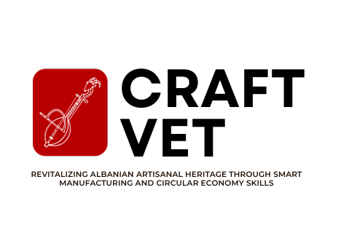

Two draft logos

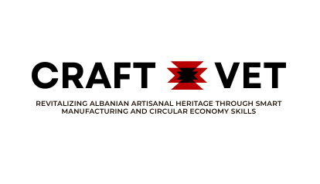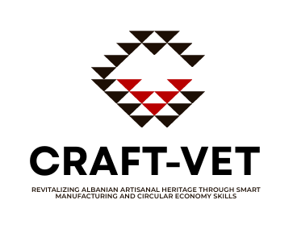

- All printed and digital materials will clearly acknowledge the support of the European Union and will follow the visibility rules of the Erasmus+ programme. Promotional materials will be used during training sessions, workshops, Circular Economy Hackathons, study visits, public events, meetings with stakeholders, fairs, conferences, and other dissemination activities.

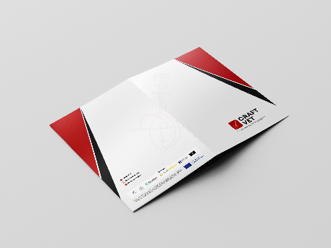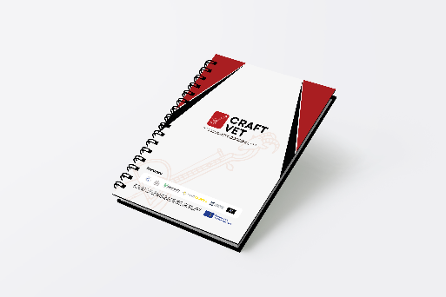

Folder Notebook

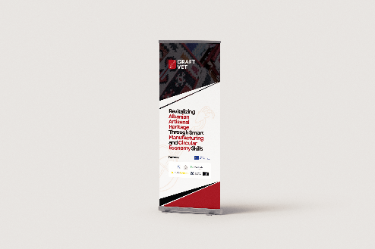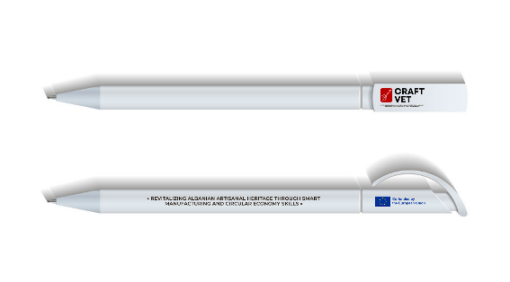
Roll UP Pen

3.2 Programme Logo and EU Visibility

All CRAFT-VET communication and dissemination outputs will respect the visibility requirements of the Erasmus+ programme and the European Union. The European Union emblem will be displayed in a visible and appropriate way on all project materials, together with the required funding acknowledgement.



The following statement will be used where applicable:
“Funded by the European Union. Views and opinions expressed are however those of the author(s) only and do not necessarily reflect those of the European Union or the European Education and Culture Executive Agency. Neither the European Union nor the granting authority can be held responsible for them.”

This disclaimer will be included in project deliverables, publications, reports, promotional materials, training documents, online resources, and any other official outputs produced within the project.

Partners will ensure that the EU emblem and funding statement are used correctly in:
- deliverables and reports;
- presentations;
- website pages;
- newsletters;
- social media posts;
- brochures and posters;
- event materials;
- videos and digital content;
- certificates and attendance documents.

The consistent use of the EU visual identity will help ensure transparency regarding the project funding and will contribute to the wider visibility of Erasmus+ support in the field of vocational education and training.

3.3 CRAFT-VET Website

The CRAFT-VET website will be one of the main tools for external communication and dissemination. It will serve as a public information point where stakeholders can access updated information about the project, its objectives, partners, activities, results, events, and outputs.

The website will be designed to be user-friendly, accessible, and regularly updated throughout the project lifetime. It will present the project in a clear and attractive way, using language that is understandable for both professional and general audiences. The website will also support the visibility of Albanian artisanal heritage and promote the role of VET in connecting traditional crafts with digital and green skills.

The website will include information about:
- the project background and objectives;
- the consortium partners;
- Smart Craft Labs;
- training modules and learning resources;
- circular economy activities;
- digital craft tools and innovation;
- blockchain-based certification;
- project news and events;
- newsletters;
- project deliverables and public reports;
- photos and videos from activities;
- contact information.

The main sections of the website may include:
- Home;
- About the Project;
- Partners;
- Activities;
- Smart Craft Labs;
- Training and Resources;
- News and Events;
- Results;
- Digital Craft Marketplace / Platform;
- Contact.

The website will also be used to publish public project outputs, such as training materials, guidelines, policy recommendations, newsletters, reports, and promotional content. It will support the sustainability of the project by keeping project results available after the end of EU funding.

CRAFT VET Website: CraftVET – Erasmus & Capacity Building in VET project

All partners will contribute to the website by providing news, photos, short articles, event summaries, success stories, and other relevant updates from their institutions and countries.

3.4 Social Media

Social media will be used to increase the visibility of CRAFT-VET and to reach different audiences in a direct, accessible, and engaging way. Social media channels will be especially important for reaching young people, VET students, artisans, craft businesses, local communities, and the general public.

Dedicated CRAFT-VET social media accounts will be created and regularly updated. The most relevant platforms will include Facebook, LinkedIn and Instagram. Other platforms may also be considered if they are useful for reaching specific target groups.

Social media will be used to share:
- project news and announcements;
- information about training opportunities;
- photos and videos from activities;
- stories of artisans and VET students;
- updates from Smart Craft Labs;
- examples of sustainable craft practices;
- information about Circular Economy Hackathons;
- promotional posts about Albanian crafts;
- partner activities;
- project results and publications;
- event invitations and follow-up posts.

The tone of social media communication will be clear, positive, inclusive, and visually attractive. Posts will highlight the practical benefits of the project and will show how CRAFT-VET contributes to skills development, youth employability, women’s participation, innovation, sustainability, and cultural heritage preservation.

All partners will support the social media presence of the project by sharing posts through their institutional accounts and by providing content from local activities. Whenever possible, posts will include photos, short videos, testimonials, quotes from participants, and examples of project impact.

3.4.1 KPIs for social media and Online Communication

The effectiveness of CRAFT-VET online communication will be monitored through simple and measurable indicators. These indicators will help the consortium understand whether the project is reaching its audiences and whether communication activities need to be improved.

Channel / Tool | Objective | Target Audience | KPI / Target | Way of Measurement
Project website | Present the project, partners, activities, outputs and results | VET institutions, artisans, students, authorities, businesses, general public | At least 3,000 visits during the project lifetime | Website analytics
Facebook | Raise awareness and promote project activities | Students, artisans, local communities, general public | At least 400 followers by the end of the project | Social media analytics
LinkedIn | Reach professional and institutional stakeholders | VET providers, policy makers, business networks, EU partners | At least 400 followers by the end of the project | LinkedIn analytics
Instagram | Promote visual content related to crafts, labs and events | Young people, students, artisans, general public | At least 500 followers by the end of the project | Instagram analytics
Partner websites | Increase visibility through institutional networks | Institutional audiences and external stakeholders | At least one project-related update per partner per year | Partner reports
Media coverage | Inform the wider public about project relevance and results | General public, local and national audiences | At least 2 media appearances/articles during the project | Media monitoring
These KPIs may be revised during the project implementation if the consortium identifies new dissemination opportunities or if additional communication channels are introduced.

3.5 Erasmus+ Project Results Platform
The Erasmus+ Project Results Platform will be used as an official channel for disseminating the main results and outputs of the CRAFT-VET project. It will support the visibility of the project at European level and will ensure that the results remain accessible to a wider audience after the end of the project.
The consortium will upload the relevant public outputs, including:
- project summary;
- public deliverables;
- training materials;
- guidelines and manuals;
- policy recommendations;
- dissemination materials;
- sustainability-related outputs;
- other relevant project results.
The project summary on the platform will present the background, objectives, activities, target groups, methodology, results, expected impact, and long-term benefits of CRAFT-VET.
The platform will also support the transferability of the project results to other VET institutions, craft-related initiatives, and organisations working in the areas of cultural heritage, digital skills, circular economy, and entrepreneurship.

3.6 Web Pages of Consortium Members
The websites and communication channels of consortium members will be used to multiply the visibility of CRAFT-VET. Each partner will publish information about the project on its institutional website, including a short description of the project, the EU funding acknowledgement, the project logo, and a link to the official project website.
Partner websites will also be used to disseminate:
- project news;
- event announcements;
- training opportunities;
- reports from workshops and meetings;
- photos and videos;
- public deliverables;
- final results.
This approach will help the project reach the existing networks of each partner and will increase awareness among institutional audiences, students, staff, local stakeholders, and professional communities.

3.7 Internal Communication
Internal communication is essential for ensuring smooth cooperation between CRAFT-VET partners. It will support coordination, planning, implementation, reporting, quality assurance, and dissemination.
The internal communication of the project will be based on transparency, regular exchange of information, shared responsibility, and timely decision-making. All partners will contribute actively to communication and dissemination activities by providing information from their own tasks, events, results, and local contexts.
The project coordinator and the partner responsible for dissemination will guide the communication process and will ensure that partners use common templates, follow EU visibility rules, and report dissemination activities properly.
Internal communication will include:
- regular project meetings;
- online coordination meetings;
- email communication;
- shared folders for documents;
- templates for reporting and dissemination;
- internal deadlines for providing content;
- partner updates on communication activities.
A common repository, such as Google Drive or another shared platform, will be used to store project documents, templates, photos, presentations, reports, and dissemination evidence.

3.7.1 Direct Communication
Direct communication will take place through official project meetings, working group meetings, training events, workshops, and informal coordination between partners. These meetings will allow partners to discuss progress, plan activities, solve challenges, and coordinate dissemination actions.
Direct communication will be particularly important before and after major project activities, such as:
- kick-off meeting;
- training sessions;
- Smart Craft Lab activities;
- Circular Economy Hackathons;
- study visits;
- stakeholder roundtables;
- dissemination events;
- final conference.
The hosting partner of each event will coordinate with the project coordinator and dissemination leader to ensure that communication materials, attendance lists, photos, agendas, presentations, and event reports are properly prepared and archived.

3.7.2 Electronic Communication
Electronic communication will be the main tool for day-to-day project coordination. Email will be used for official communication between partners, while online meetings will be organised through platforms such as Zoom, Microsoft Teams, or Google Meet.
A shared online folder will be used for exchanging and storing documents. This will help partners access the latest versions of templates, reports, communication materials, deliverables, and evidence of dissemination activities.
For dissemination and reporting purposes, partners will use common templates such as:
- meeting agenda template;
- minutes template;
- attendance list;
- event report form;
- communication activity form;
- presentation template;
- photo consent form, where needed;
- dissemination evidence folder.
This will ensure consistency in project documentation and will make it easier to monitor the implementation of dissemination activities.

3.8 Mass Media
Mass media will be used to inform the wider public about the CRAFT-VET project and its contribution to vocational education, cultural heritage, sustainability, entrepreneurship, and youth employment.
The project will seek visibility through:
- local and national newspapers;
- online media portals;
- radio and TV channels;
- institutional press releases;
- interviews with project representatives;
- articles about project events and results.
Media communication will be especially relevant during important project moments, such as the project launch, opening of Smart Craft Labs, major training events, Circular Economy Hackathons, participation in fairs, policy roundtables, and the final conference.
The consortium will prepare press releases and media information in a clear and concise format. Partners will adapt media messages to their national and local contexts and will use their existing contacts with journalists, media outlets, and communication offices.

3.9 Participation in Targeted Events
Participation in targeted events will be an important dissemination tool for CRAFT-VET. These events will allow partners to present the project, share results, build networks, and create opportunities for cooperation with relevant stakeholders.
CRAFT-VET will be presented at:
- VET-related events;
- education and training conferences;
- craft fairs and exhibitions;
- entrepreneurship events;
- cultural heritage events;
- circular economy and sustainability events;
- local and national stakeholder meetings;
- EU and regional networking events;
- policy roundtables;
- business and tourism-related events.
Through these events, the project will reach artisans, students, teachers, policy makers, business representatives, local authorities, and other organisations interested in craft development and vocational education.
Partners participating in external events will use project presentation materials and will report the dissemination activity using the common communication activity form. Evidence such as photos, agendas, participant lists, links, and short summaries will be collected for reporting purposes.

  - DATA PROTECTION AND PROCESSING BY THE BENEFICIARIES
The beneficiaries must process personal data under the Agreement in compliance with the applicable EU, international and national law on data protection. They must ensure that personal data is:
- processed lawfully, fairly and in a transparent manner in relation to the data subjects.
- collected for specified, explicit and legitimate purposes and not further processed in a manner that is incompatible with those purposes.
- adequate, relevant and limited to what is necessary in relation to the purposes for which they are processed.
- accurate and, where necessary, kept up to date.
- kept in a form which permits identification of data subjects for no longer than is necessary for the purposes for which the data is processed and
- processed in a manner that ensures appropriate security of the data.
The beneficiaries may grant their personnel access to personal data only if it is strictly necessary for implementing, managing, and monitoring the Agreement. The beneficiaries must ensure that the personnel is under a confidentiality obligation.
For more information on EU Regulation and compliance with data protection laws, refer to Article 15 of the Grant Agreement.

  - ANNEXES
Word document template

REPORT ON XXXXXXXX
XXXXXXXXXXXXXX

Funded by the European Union. Views and opinions expressed are however those of the author(s) only and do not necessarily reflect those of the European Union. Neither the European Union nor the granting authority can be held responsible for them.
CRAFT-VET - Revitalizing Albanian Artisanal Heritage Through Smart Manufacturing and Circular Economy Skills

Project: xxxxxxxxxxx - ERASMUS-EDU-2025-CBHE

PROJECT INFO
Project title | Text
Project acronym | Text
Project reference number | Text
Funding scheme | Text
Web address | Text
Coordination institution | Text
Project duration | Text

DOCUMENT CONTROL SHEET
Work package | Text
Ref. no and title of activity | Text
Title of deliverable | Text
Lead institution | Text
Author(s) | Text
Document status | Text
Document version and date | Text
Dissemination level | Text

VERSIONING AND CONTRIBUTION HISTORY
Version | Date | Revision description | Partner responsible
v.01

Heading First
Lorem ipsum dolor sit amet, consectetur adipiscing elit, sed do eiusmod tempor incididunt ut labore et dolore magna aliqua. Ut enim ad minim veniam, quis nostrud exercitation ullamco laboris nisi ut aliquip ex ea commodo consequat. Duis aute irure dolor in reprehenderit in voluptate velit esse cillum dolore eu fugiat nulla pariatur. Excepteur sint occaecat cupidatat non proident, sunt in culpa qui officia deserunt mollit anim id est laborum.
Heading Second
Lorem ipsum dolor sit amet, consectetur adipiscing elit, sed do eiusmod tempor incididunt ut labore et dolore magna aliqua. Ut enim ad minim veniam, quis nostrud exercitation ullamco laboris nisi ut aliquip ex ea commodo consequat. Duis aute irure dolor in reprehenderit in voluptate velit esse cillum dolore eu fugiat nulla pariatur. Excepteur sint occaecat cupidatat non proident, sunt in culpa qui officia deserunt mollit anim id est laborum.
Heading the third
Lorem ipsum dolor sit amet, consectetur adipiscing elit, sed do eiusmod tempor incididunt ut labore
et dolore magna aliqua. Ut enim ad minim veniam, quis nostrud exercitation ullamco laboris nisi ut aliquip ex ea commodo consequat. Duis aute irure dolor in reprehenderit in voluptate velit esse cillum dolore eu fugiat nulla pariatur. Excepteur sint occaecat cupidatat non proident, sunt in culpa qui officia deserunt mollit anim id est laborum.
Lorem ipsum dolor sit amet, consectetur adipiscing elit, sed do eiusmod tempor incididunt ut labore et dolore magna aliqua. Ut enim ad minim veniam, quis nostrud exercitation ullamco laboris nisi ut aliquip ex ea commodo consequat. Duis aute irure dolor in reprehenderit in voluptate velit esse cillum dolore eu fugiat nulla pariatur. Excepteur sint occaecat cupidatat non proident, sunt in culpa qui officia deserunt mollit anim id est laborum
Lorem ipsum dolor sit amet, consectetur adipiscing elit, sed do eiusmod tempor incididunt ut labore et dolore magna aliqua. Ut enim ad minim veniam, quis nostrud exercitation ullamco laboris nisi ut aliquip ex ea commodo consequat. Duis aute irure dolor in reprehenderit in voluptate velit esse cillum dolore eu fugiat nulla pariatur. Excepteur sint occaecat cupidatat non proident, sunt in culpa qui officia deserunt mollit anim id est laborum
Lorem ipsum dolor sit amet, consectetur adipiscing elit, sed do eiusmod tempor incididunt ut labore et dolore magna aliqua. Ut enim ad minim veniam, quis nostrud exercitation ullamco laboris nisi ut aliquip ex ea commodo consequat. Duis aute irure dolor in reprehenderit in voluptate velit esse cillum dolore eu fugiat nulla pariatur. Excepteur sint occaecat cupidatat non proident, sunt in culpa qui officia deserunt mollit anim id est laborum
Lorem ipsum dolor sit amet, consectetur adipiscing elit, sed do eiusmod tempor incididunt ut labore et dolore magna aliqua. Ut enim ad minim veniam, quis nostrud exercitation ullamco laboris nisi ut aliquip ex ea commodo consequat. Duis aute irure dolor in reprehenderit in voluptate velit essecillum dolore eu fugiat nulla pariatur. Excepteur sint occaecat cupidatat non proident, sunt in culpa qui officia deserunt mollit anim id est laborum.

Heading Second
Lorem ipsum dolor sit amet, consectetur adipiscing elit, sed do eiusmod tempor incididunt ut labore et dolore magna aliqua. Ut enim ad minim veniam, quis nostrud exercitation ullamco laboris nisi ut aliquip ex ea commodo consequat. Duis aute irure dolor in reprehenderit in voluptate velit esse cillum dolore eu fugiat nulla pariatur. Excepteur sint occaecat cupidatat non proident, sunt in culpa qui officia deserunt mollit anim id est laborum.
Heading the third
Lorem ipsum dolor sit amet, consectetur adipiscing elit, sed do eiusmod tempor incididunt ut labore et dolore magna aliqua. Ut enim ad minim veniam, quis nostrud exercitation ullamco laboris nisi ut aliquip ex ea commodo consequat. Duis aute irure dolor in reprehenderit in voluptate velit esse cillum dolore eu fugiat nulla pariatur. Excepteur sint occaecat cupidatat non proident, sunt in culpa qui officia deserunt mollit anim id est laborum.
Heading Second
Lorem ipsum dolor sit amet, consectetur adipiscing elit, sed do eiusmod tempor incididunt ut labore et dolore magna aliqua. Ut enim ad minim veniam, quis nostrud exercitation ullamco laboris nisi ut aliquip ex ea commodo consequat. Duis aute irure dolor in reprehenderit in voluptate velit esse cillum dolore eu fugiat nulla pariatur. Excepteur sint occaecat cupidatat non proident, sunt in culpa qui officia deserunt mollit anim id est laborum.
Heading the third
Lorem ipsum dolor sit amet, consectetur adipiscing elit, sed do eiusmod tempor incididunt ut labore et dolore magna aliqua. Ut enim ad minim veniam, quis nostrud exercitation ullamco laboris nisi ut aliquip ex ea commodo consequat. Duis aute irure dolor in reprehenderit in voluptate velit esse cillum dolore eu fugiat nulla pariatur. Excepteur sint occaecat cupidatat non proident, sunt in culpa qui officia deserunt mollit anim id est laborum.
Heading Second
Lorem ipsum dolor sit amet, consectetur adipiscing elit, sed do eiusmod tempor incididunt ut labore et dolore magna aliqua. Ut enim ad minim veniam, quis nostrud exercitation ullamco laboris nisi ut aliquip ex ea commodo consequat. Duis aute irure dolor in reprehenderit in voluptate velit esse cillum dolore eu fugiat nulla pariatur. Excepteur sint occaecat cupidatat non proident, sunt in culpa qui officia deserunt mollit anim id est laborum.
Meeting Agenda form

Agenda
Kick-off meeting

Project Title: Text
Acronym: Text
Project Nº: Text

Work package | Title
1 | Text
Task No | Task name
T1.1 | Coordination meeting (kick-off)

Dates | Text
City | Text
Meeting venue | Text
Address | Text
Thursday, 23rd February 2023
9:00-9:30
First session
9:30-9:35
9:35-9:50
9:50-10:10
10:10-10:20
10:20-10:30
10:30-11:00
Second session
11:00-11:15
11:15-11:40
11:40-12:00
12:00-12:30
Third session
12:30-12:40
12:40-12:50
12:50-13:00
13:00-13:10
13:10-13:20
13:20-14:50
14:50-15:00
15:00-15:10
15:10-15:20
15:20-15:30
15:30-15:40
15:40-15:50
15:50-16:00
16:00-16:10
16:10-16:20
16:20-16:40
16:40-16:45
16:45-16:50

Dissemination and Communication activity form

DISSEMINATION AND
COMMUNICATION ACTIVITY FORM

Funded by the European Union. Views and opinions expressed are however those of the author(s) only and do not necessarily reflect those of the European Union. Neither the European Union nor the granting authority can be held responsible for them.
CRAFT-VET - Revitalizing Albanian Artisanal Heritage Through Smart Manufacturing and Circular Economy Skills

Project: xxxxxxxxxxx - ERASMUS-EDU-2025-CBHE
Date | Text
Place | Text
Author | Text
Institution | Text

Communication activity description
Communication activity name
Who? Target audience (Please select only one option) | ☒ Industry, business partners  ☐ Innovators  ☐ Investors  ☐ EU institutions  ☐ National authorities  ☐ Regional authorities | ☐ Local authorities  ☐ Civil society  ☐ Citizens  ☐ Research communities  ☐ Specific user communities (if applicable)  ☐ International organisation (UN body, OECD, etc.)
How? Communication channel  (Please select only one option) | ☐ Event (conference, meeting, workshop, internet debate, round table, discussion, etc.)  ☐ Exhibition  ☐ Interview  ☐ Media article  ☐ Newsletter  ☐ Other | ☐ Press release  ☐ Print materials (brochure, leaflet, posters, stickers, banners, etc.)  ☐ Social media  ☐ TV/Radio campaign  ☐ Video  ☐ Website
Outcome (very specific Key performance indicators)
Status | ☐ Cancelled  ☐ Delivered  ☐ Ongoing  ☐ Postponed
Description of the communication activity:

Communication activity description

Dissemination activity name
What?  Type of dissemination activity  (Please select only one option) | ☐ Clustering activities  ☐ Collaboration with EU-funded projects  ☐ Conferences  ☐ Education and training events  ☐ Meetings  ☐ Other  ☐ Other scientific collaboration
Who?  Target audience reached  (You can choose multiple options) | ☐ Industry, business partners  ☐ Innovators  ☐ EU institutions  ☐ National authorities  ☐ Regional authorities  ☐ Local authorities  ☐ Civil society | ☐ Citizens  ☐ Research communities  ☐ Specific end user communities  ☐ International organisation (UN body, OECD, etc.)  ☐ Other  ☐ Investors
Status of the dissemination activity | ☐ Cancelled  ☐ Delivered  ☐ Ongoing  ☐ Postponed

Why? Description of the objective(s) with reference to a specific project output

(max. 200 characters):

Attendance list template

ATTENDANCE LIST

Funded by the European Union. Views and opinions expressed are however those of the author(s) only and do not necessarily reflect those of the European Union. Neither the European Union nor the granting authority can be held responsible for them.
CRAFT-VET - Revitalizing Albanian Artisanal Heritage Through Smart Manufacturing and Circular Economy Skills

Project: xxxxxxxxxxx - ERASMUS-EDU-2025-CBHE

Type of event | Text
Venue | Text
Date | Text
Organizer | Text

No. | Name | Institution acronym | E-mail | Signature | I would like to opt out from being photographed at the event
1
2
3
4
5
6
7
8
9
10
11
12
13
14
15
16
17
18
19
20

